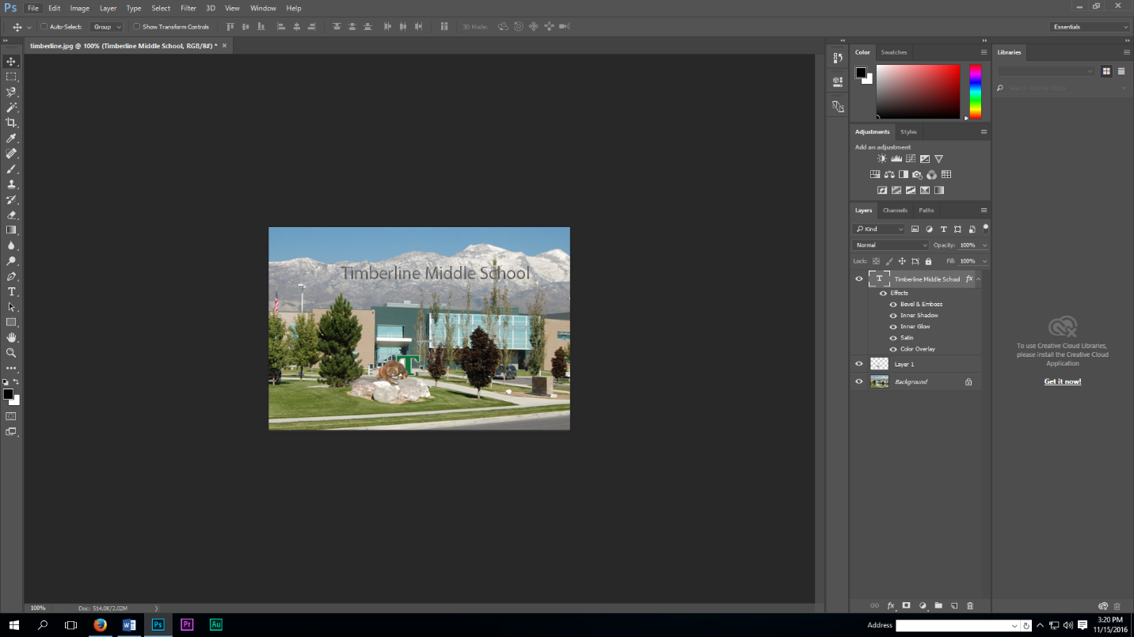

Eye Icon

Magic Wand Toolnd Tool

Move Tool Tool

Lasso Tool

Menu Bar

1. Click on the images **timberline.jpg** and **bear.jpg** from Canvas and save to your computer desktop or Z:/Digital Literacy/Photoshop.

*Photoshop Info. Sheet IC 1-2*

1. Open up **Adobe Photoshop**.
2. Click on the **Menu Bar File/Open** and browse for the desktop or Z: (where you saved your image). Click on **timberline.jpg** and **bear.jpg** to open up in Photoshop.
3. Click on the **Menu bar/Window/Arrange/Tile all Vertically**. You will see the images side by side.
4. Click on the **Move Tool** and select the **bear** & **drag it on top of the timberline.jpg.**
5. **Close** the **bear.jpg** once the duplicate bear image is moved to timberline.jpg
6. Click on the **Menu Bar File/Save** **As IC1-2** and format as a .PSD (Photoshop document) on the Z:/Digital Literacy/Photoshop.
7. Click on the **Move Tool** and move the image to where you want it on the page and adjust the **size** of the bear by clicking on **Edit/Transform/Scale** **(CTRL-T)** and click **OK** on transformation.
8. Get rid of the white background on the bear by selecting the bear with the **lasso** or **magic wand tool.**
   1. Click on the **eye icon** in the Layers palette to get rid of **Timberline background**.
   2. Select the **magic wand** or **lasso tool** and go around the bear with them.
   3. Press the **delete key** to get rid of the white background.
   4. Turn the **eye icon** back on to see the full image of Timberline School.
   5. Make final adjustments to where you want your bear placed.
9. **Repeat steps 3-9 again** to add some **additional images** of your choice to the picture - be creative and have fun
10. Click on the **Text Tool** and choose a **font, color**, and **size** of your choice and **type** some text that will be fitting for this image.
11. Select the **Move tool** and adjust your text.
12. Add a **drop shadow** to your **text** by clicking on the **Menu Bar Layer/Layer Style/Style Settings.** Try the different settings to your text and find a look that you like.
13. Click on the **Menu Bar/File/Save As** and name it **IC1-2** and select .**jpg** for the format and **submit on Canvas**.