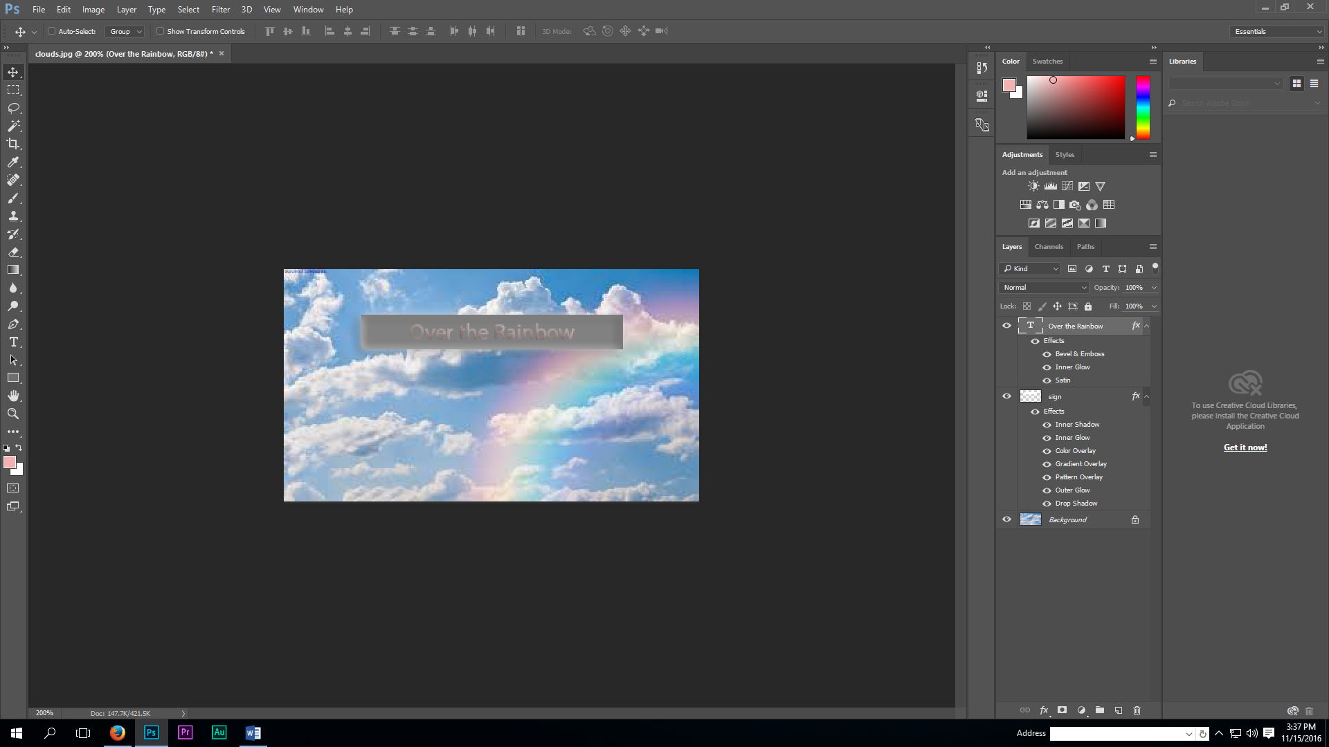
- Click the file clouds.jpg from Canvas and save the image to the desktop or Z:/Digital Literacy/Photoshop.
Text Tool
Rectangular Marquee Tool
Tool Bar
Menu Bar
Foreground/Background Color
Photoshop Info. Sheet IC1-1

- Open up Adobe Photoshop.

- Click on the Menu Bar File/Open and browse for the desktop or Z: (where you saved your image). Click on clouds.jpg to open up in Photoshop.

- Click on the Menu Bar File/Save As IC1-1 as a .PSD (Photoshop document) on the network drive (Z: Digital Literacy/Photoshop folder) Make sure to save often as you work through the assignment.

- Click on the Menu Bar View and select 200% to make the image larger (keep in mind we are working with individual pixels)( CTRL+ makes it larger (CTRL – makes it smaller)

- Click on the Menu Bar and select Layer/New/Layer and name the new layer “Sign” and click OK.

- On the Toolbar, set the Foreground to a color of your choice.

- Select the Rectangular Marquee Tool, make a rectangular box for a sign
(CTRL-D will deselect the box, if you want to redo it)

- Select the Menu Bar/Edit/Fill Selection/Foreground Color/OK.

- Give the sign some texture by selecting on the Menu bar/ Filter/ and choosing a Filter of your choice -play with the settings.

- Click on the Text Tool and choose a font, color, and alignment of your choice.

- Type some text of your choice on your sign that will be fitting for this image.

- Select the Move Tool and adjust your text onto the sign. (rectangular box)

- Add a drop shadow to your text by clicking on the Menu bar Layer/Layer Style/Style Settings. Try the different settings to your text and find a look that you like.

- Click on the Menu Bar/File/Save As and name it IC1-1 and choose .jpg for the format and submit on Canvas.

