HTML | INFORMATION SHEET

index.html
- Open up Notepad++
- Click on File/New
- Copy and paste the doctype below into the text editor. A doctype declaration refers to the rules for the markup language, so that the browser renders the content correctly.
<!DOCTYPE html>
<html>
<head>
<title>
</title>
</head>
<body>
</body>
</html>

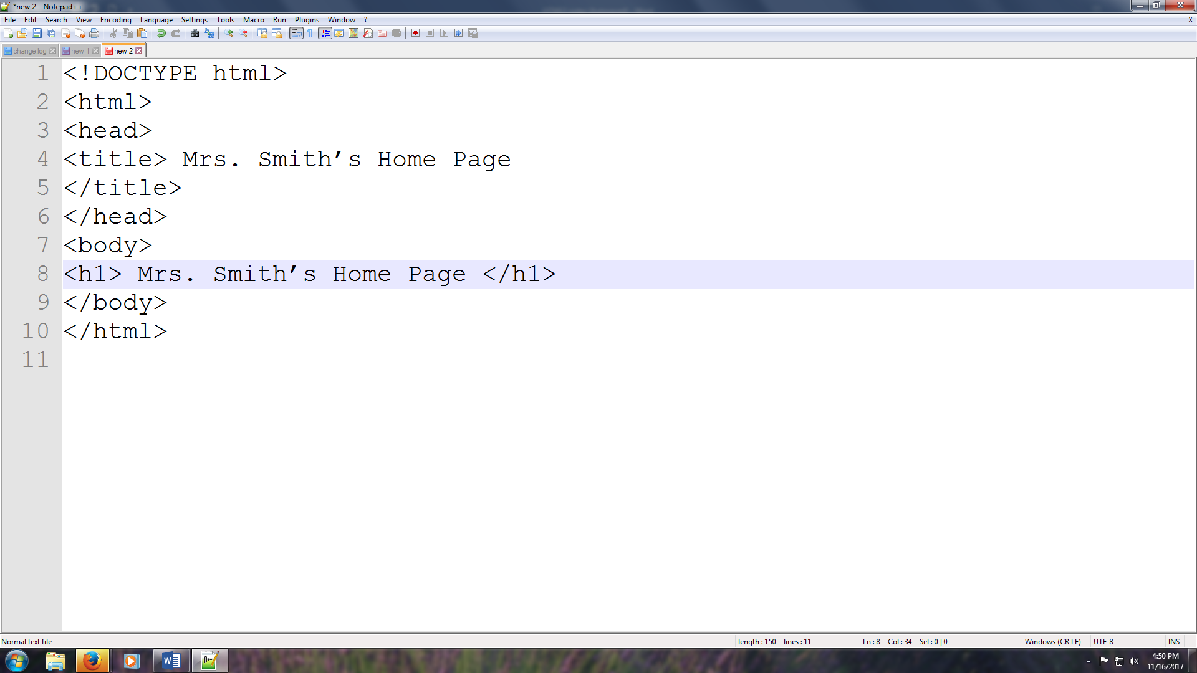
- Between the <title> Mrs. Smith’s Home Page </title> tags, give the first page a title.
- After the < body> tag
type <h1> Mrs. Smith’s Home Page</h1> (<h1> largest heading)

- Click on File/Save As & type index for the file name. Index is the name of the first page of any website.
- In the Save As type select hypertextmarkup language (*.html) and create a new folder named First LastName Website.
- Preview your website by selecting Run on the Menu bar & choose a browser of your choice.
- Go back into Notepad++ & add a <hr> (horizontal rule) right below </h1>.
- Type an opening and closing <blockquote> paragraph about yourself </blockquote> paragraph tags below the <hr>.
- Type below the </blockquote>
<h2> Favorite Things </h2>
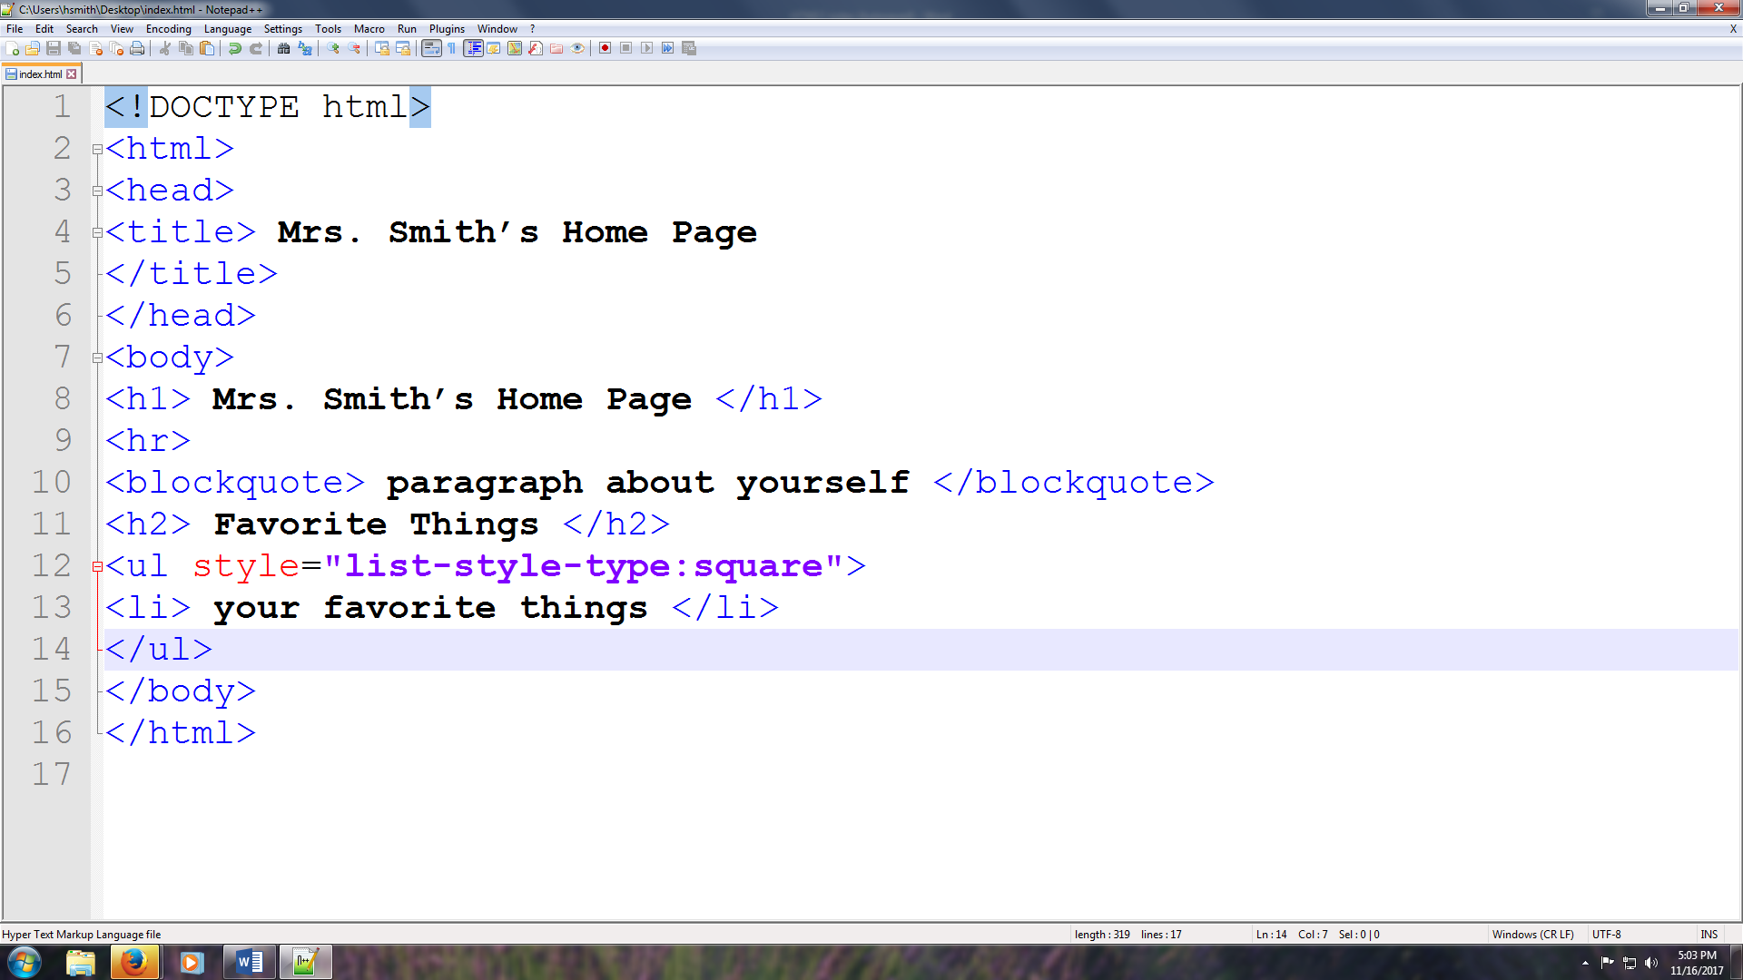
- Next, we will create an unordered list by typing <ul style="list-style-type:square"> (unordered list – square bullets)
- Type <li> your favorite things </li>
- Repeat Step 13 four times and between the <li></li> tags type (favorite class, favorite day of the week, favorite movie, favorite TV show)
- Close the </ul> tag
- Save and reload to the web
- We will now create a navigational bar to the new pages that we’ll be creating. We will be typing after </ul> tag
<h3>|<a href="index.html"> home </a> | | <a href="family.html">family</a> |<a href="school.html">school</a> | <a href="hobbies.html">hobbies |</a></h3>
- Save and reload to the web & click on the links for the navigational bar.
- Now that our index page is just straight text, we are going to add some CSS for color, & style to our web page. Click on File/New in your Notepad++ and we will be creating an external style sheet to connect to our index page. Copy & paste the following CSS in bold.
body
{
background-color:teal;
}
hr
{
color:sienna;
}
h1
{
text-align:center;
font-size:72px;
color:orange;
}
h2
{
color:pink;
}

h3
{
text-align:center;
font-size:30px;
}
ul
{
font-size:20px;
color:pink;
}
blockquote
{
font-size:30px;
color:orange;
}
- Click on File/Save As & name it mystyles.css. Choose Cascade Style Sheets File (.*css) (Your styles sheet will give your web page some nice format)
- Now we will connect the external style sheet to our index page by copying the following link below in bold:
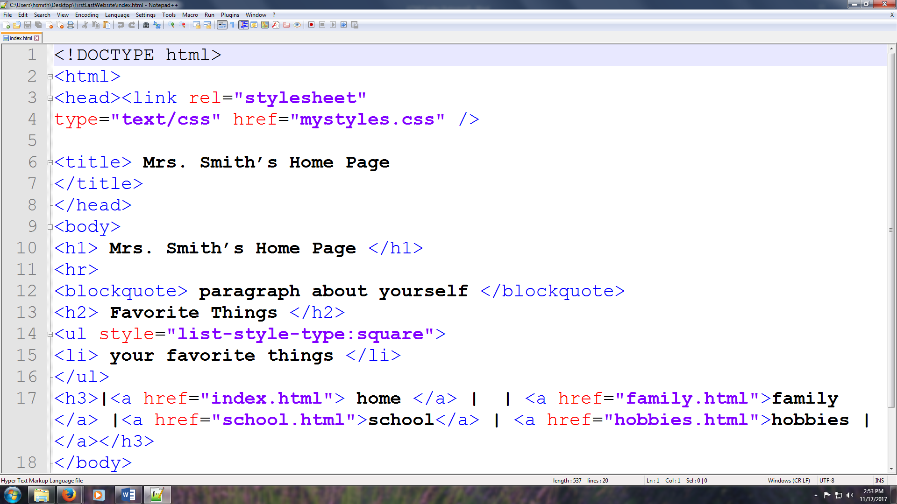
After the opening <head> tag
<link rel="stylesheet"
type="text/css" href="mystyles.css" />
- Now let’s load it into the internet.
- Now you will be creating additional pages named:
family.html
school.html
hobbies.html
- Be creative and have fun!!!!

