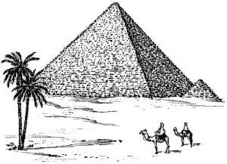
Name:

Class Period:

9th Grade Unit 2 – Middle East

Date | Daily Schedule | Learning Target
Sept.  18, 19 | 2.1 Middle East Map  - Make a map of the Middle East  - Countries, capitals, landforms
Sept.  20, 21 | 2.2 Agricultural Revolution  - Paleolithic vs. Neolithic  - Steps to farming  - Fertile Crescent
Sept.  24, 25 | 2.2 Agricultural Revolution  - Impact on human civilizations  - Climate of the region
Sept.  26, 27 | 2.3 Mesopotamia  - Civilizations of the Fertile Crescent  - Sumerians, Persians, Phoenicians, Assyrians
Sept. 28  Oct. 1 | 2.4 Egypt  - Farming and Nile River  - Religion  - Pharaohs and slavery
Oct.  2, 3 | 2.4 Egypt  - Afterlife  - Burial
Oct.  4, 5 | 2.5 Christianity  - History of Christianity
Oct.  8, 9 | 2.5 Judaism  - History of Judaism
Oct.  10, 11 | 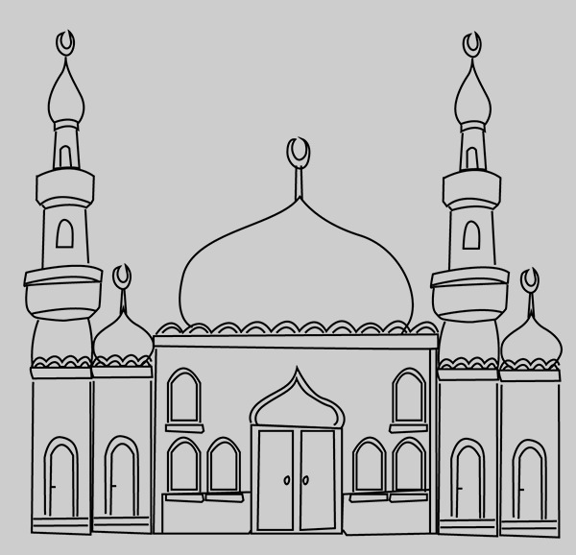  2.5 Islam  - History of Islam

Date | Daily Schedule | Learning Target
Oct.  12, 15 | 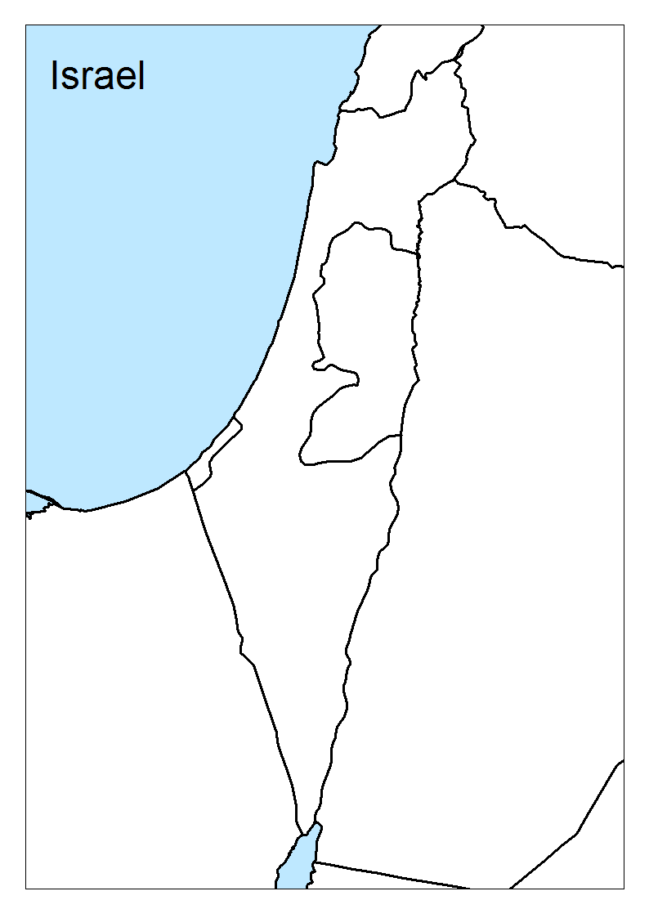  2.6 Palestinian/Israeli Conflict  - Background to conflict  - UN plans and resolutions  - Fighting today
Oct.  16, 17 | 2.6 Palestinian/Israeli Conflict  - Primary source day
Oct.  23, 24 | 2.7 Persian Gulf War  - Rise of Saddam Hussein  - Invasion of Kuwait  - Fight over oil
Oct.  25, 26 | 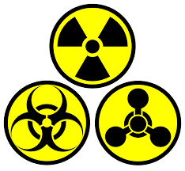  2.8 Modern Middle East  - War in Iraq  - Terrorism and WMD’s  - ISIS and Al Qaeda
Oct.  29, 30 | Unit 2 Review
Oct. 31  Nov. 1 | Unit 2 Test – Middle East

Assessment Schedule
September 20, 21 | Sept. 28, Oct. 1 | October 4, 5
2.1 – Middle East Map Quiz | 2.2 – Agricultural Revolution  2.3 – Mesopotamia  Bubble Sheet Quiz | 2.4 – Egypt  Bubble Sheet Quiz

October 12, 15 | October 16, 17 | Oct. 31, Nov. 1 - TEST
2.5 – Religions  Comparison Chart | 2.6 – Palestine/Israel Conflict  DBQ (Claim) | DOK 1  DOK 2  DOK 3

