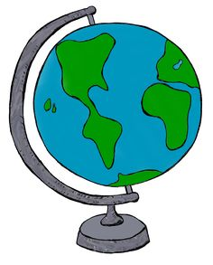
Name:

Class Period:

9th Grade Unit 1 – Physical and Human Geography

Date | Daily Schedule | Learning Target
August  20, 21 | 1.1 World Map  - Class Introduction  - Procedures  - Continents vs. Regions
August  22, 23 | 1.2 Latitude and Longitude  - Grid System  - Coordinates
August  24, 27 | 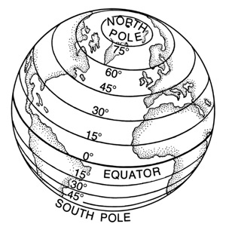  1.3 Mapping Skills  - Distortions  - 5 parts of a map
August  28, 29 | 1.2 and 1.3 Skills Day  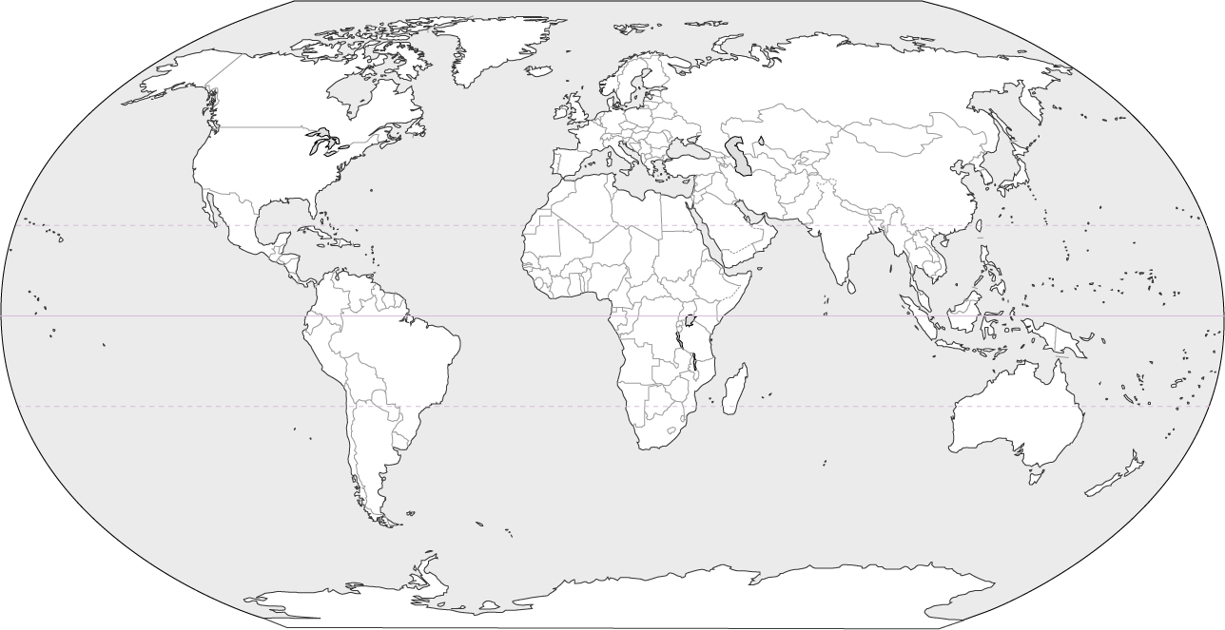  - Reading and interpreting maps
August  30, 31 | 1.4 Climate Zones  - Weather vs. Climate  - 3 climate zones
Sept.  4, 5 | 1.4 Climate Zones  - Population  - Map interpretations  - Cartograms
Sept.  6, 7 | 1.5 Global Issues – Physical  - Climate issues  - Water and air pollution  - Deforestation  - Natural Disasters
Sept.  10, 11 | 1.6 Culture, Politics, Economics  - How culture is learned  - Political systems in the world  - Economic systems in the world

Date | Daily Schedule | Learning Target
Sept.  12, 13 | 1.7 Global Issues – Human  - Refugees  - Racism  - Gender bias
Sept.  14, 17 | Historical Skills Introduction  - Sourcing  - Corroboration  - Contextualization

Unit 1 Assessment Schedule

August 22, 23 | August 28, 29 | September 6,7
- Continents and Oceans  Map Quiz | 1.2 Latitude & 1.3 Longitude  Skills Assessment | 1.4 – Climate Zone  Bubble Sheet

