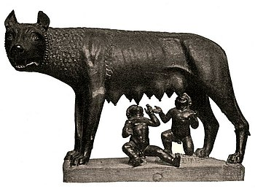
Romulus and Remus
Rhea was a princess and a mortal woman who was married to Mars, the Roman god of war. Rhea and Mars had twin sons and named them Romulus and Remus. Rhea’s father was defeated by her uncle and took the throne. The uncle wanted to kill Romulus and Remus so he wouldn’t ever have to give up the thrown to heirs. Rhea heard about the plot. Since Mars was away she needed to protect the boys. She put them in a basket and set it floating down the Tiber River hoping that they would be found. The basket came to rest on the bank of the river and the boys were found by a female wolf who decided to raise them as her own cubs. She saved their lives by feeding them her own milk, but the wolf knew she couldn't keep them so she put them where a shepherd would find them. The shepherd and his wife continued to raise Romulus and Remus.
11th/12th century (wolf) and
late 15th century (twins) attributed
to Antonio Pollaiolo. Italy
Once the boys grew and were told of their tragic background, they attacked the King who had tried to kill them and restored their grandfather to the throne. Romulus and Remus then decided to build a city where the she-wolf had saved them. They had a contest to see who would be the king. When it appeared that Remus was going to win the contest, Romulus got so angry that he killed Remus with a rock and became the first king of Rome. Tradition puts the founding of Rome by Romulus in 753 B.C.
In 27 B.C., the Roman historian Titus Livy published “Books from the Foundation of the City.” In the book, he claimed that as a god, Romulus had descended from heaven over 700 years before and prophesied that Rome would become the “caput orbis terrarum” – the Capital of the World. “Tell the Romans that by heaven’s will my Rome shall be the capital of the world. Let them learn to be soldiers. Let them know, and teach their children, that no power on earth can stand against Roman arms.”

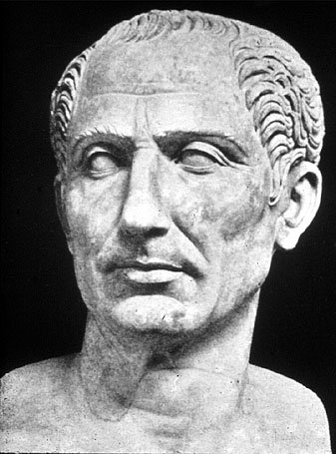
Julius Caesar
Julius Caesar was such a famous and important leader in ancient Rome that they named a month after him - July, for Julius Caesar. Julius Caesar was an able administrator and a famous general. He wrote new laws and changed and improved how to rule provinces of the empire.
The Roman Republic was in trouble. Rome was overrun with crime and people were afraid to go out into the streets. People were out of work and taxes had gone up again. The Romans were angry with their government and were demanding the government do something. Caesar spoke to the people and told them he knew what to do. The Roman citizens believed and trusted him. They wanted him to fix the problems of Rome.
Head of Julius Caesar from the
Trajan’s forum, 117-138 A.D. Italy
As Caesar gained power through the support of the people, the rest of the senate became worried that Caesar might make himself a king. The senate swore that they would never be ruled by a king again.
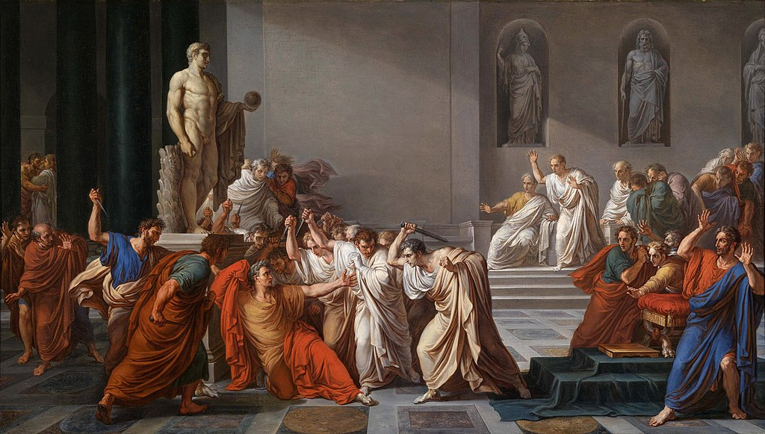
Caesar was becoming impatient with the Senate. He had his own army camped outside of the province of Italy. It was against the law for anyone to bring their private army into the territory, but he did it anyway when his troops crossed the Rubicon River. Most of the people agreed with Caesar’s action. They believed Caesar was going to solve all the problems of Rome. The Senate was forced to appoint Julius Caesar “dictator for life.”
Some senators plotted than when Caesar came before the Senate, the conspirators hid their daggers beneath their togas and attack him. He was stabbed at least 23 times. Thus, was the end of the great Julius Caesar on March 15, 44 B.C.
In 1599 A.D. William Shakespeare wrote the play “Tragedy of Julius Caesar.” In Act I, a soothsayer (witch) warns Julius to “Beware the ides of March.” Later in the famous climax of Act III, Caesar is stabbed by the conspirators on March 15th--the ides of March. One of the Senators on the scene is Caesar’s best friend, Brutus. As Brutus stabs Julius in the back, Julius questions, “Et tu, Brute!” (You too, Brutus!).
Death of Caesar by Vincenzo Camuccini. Italy, 1798
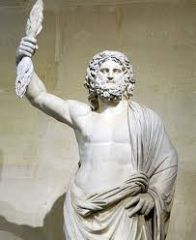
Roman Gods
The Romans had thousands of gods. They believed that there were spirits and guardian gods for everything, including trees, rocks, streams, animals, bridges, etc. The Romans believed that everything going on in the world could be explained or traced back to the actions and behaviors of the Roman Gods.
As Rome expanded, the Romans came in contact with other groups of people who worshiped different gods than the Romans. As the Romans took over these other groups of people, they often adopted these other gods and made them Roman gods. The new gods were given Roman names and were incorporated into Roman mythology stories.
Roman God Jupiter Statue from 2nd century AD
The Romans adopted the Greek gods and gave the Greek gods Roman names, and acted as if they had been Roman gods all along. But they did more than that. The ancient Romans changed some of the Greek myths to better reflect Roman beliefs and changed some of the Greek gods' personalities to better reflect the Roman way of life.
The Romans copied the story of the Greek God Zeus, who ruled from Mt. Olympus and was King of the Greek Gods to create their own God, Jupiter, who is King of the Roman Gods. Although the stories of Zeus and Jupiter differ a little, for example, Jupiter never comes down to Earth but Zeus has a habit of creating chaos by coming to earth in disguise, their stories are essentially the same. In fact, a majority if Roman mythology is copied almost directly from Greek mythology as the Romans just changed the names and stories of the Greek Gods.
The myths of the Greek Gods were changed by the Romans when the Romans conquered Greece. Although details of the stories were changed and names were switched, the basic stories remained the same. The truth about myths is that they change with the storyteller, the civilization, the times, and the translation.
A legacy of the Roman Gods lives on in the names of the planets. All of the planets, except for Earth, were named after Roman gods and goddesses. Jupiter, Saturn, Mars, Venus and Mercury were given their names thousands of years ago. Those were the planets that the ancient Romans could see in the sky without a telescope.
The other planets in our solar system were not discovered until much later, when telescopes were invented. Even then, the tradition of naming the planets after Roman gods and goddesses continued.
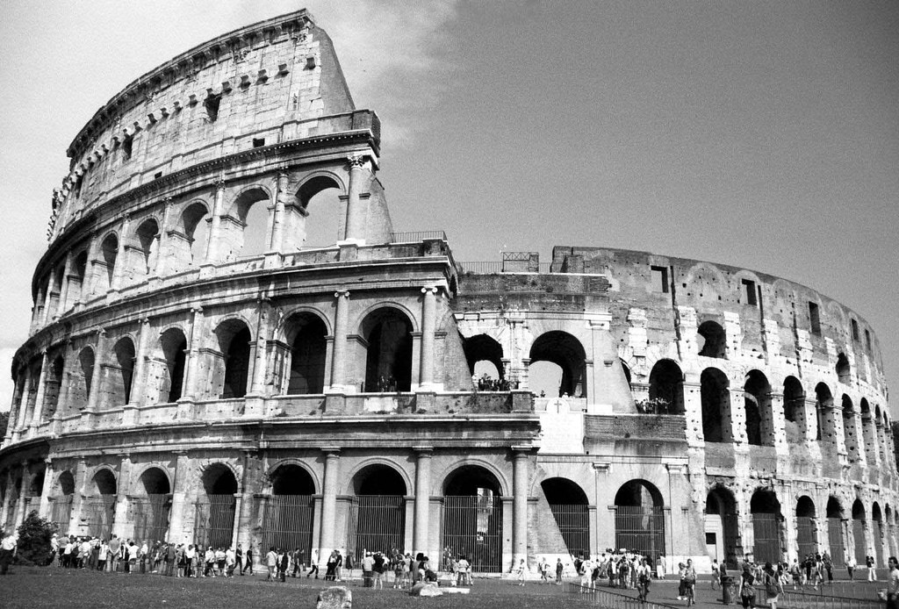
Gladiators
The Romans loved bloody sports. Entertainment became a huge part of Roman life. Games were held in the sports stadiums that were built all over the Roman Empire. The sports stadium in Rome was called the Colosseum or the Flavian Amphitheatre.
At some events, men would fight fierce animals like lions and alligators. The more interesting and exotic these animals were to the ancient Romans, the more they liked the contest. Before combat, the animals were treated very badly. They were beaten and starved so they would be especially mean. Usually, the men won. But sometimes the animals won, and the Romans found that especially exciting. But these fighters were not the famous gladiators.
The Colosseum was a public arena where gladiators fought and Romans enjoyed other violent spectacles.
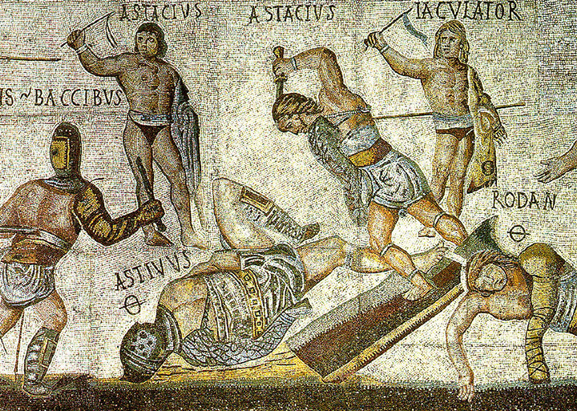
The gladiators fought other gladiators. The fights were not like you see in the movies. In ancient Rome, the gladiator battle was not always to the death. This does not mean a gladiators life was easy. Their life was not easy at all. Some people chose to become gladiators for the glory of it all. Others were slaves, forced into the sport, and usually found themselves the loser. Most gladiators would be considered a little chubby by today’s standards or what you might see in movies, although they were in excellent condition. They wanted extra body weight to help protect themselves when they were stabbed or hit. But gladiators who won most of their matches were famous. The crowds would cheer when they entered the arena.
Roman mosaic from the 4th century A.D. Italy
As time went on, the bloody fights became more organized. Gladiators were pitted against other gladiators their own size, who had won a similar number of battles. This converted the sport into competitions. There were a few women who were gladiators, and they fought other women. Referees were added to monitor the fight. A referee could stop the fight at any time, and usually did when one gladiator was injured. Sometimes, fights went on for quite a while. If the crowd got bored, the referee might call the fight a drawn. If the emperor was in attendance, he might ask the crowd for a decision on whether or not to kill the loser, but people had their favorites. They wanted their gladiators alive, so they could fight again another day.

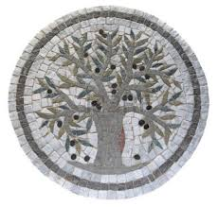
Minerva and Neptune
In ancient times, each town had a special deity, a god that looked after them.
Neptune, Lord of the Sea, was a very powerful god. He loved attention. He loved having towns build temples to worship him. He loved the gifts people brought him.
Neptune was always on the lookout for towns that had not yet been claimed by a god. He wanted as many towns as possible to call his own. Although towns could only have one god to watch over them, gods could watch over as many towns as they chose.
3rd Century A.D. Roman mosaic of olive tree
One day, Minerva, goddess of wisdom, and Neptune, lord of the sea, both claimed a coastal village. Normally, the people in the village would have been thrilled to be selected by a god to watch over them. But two gods at once? A town could have only one guardian, and they did not want to choose. They did not want to anger either god.
Minerva, who was wise as well as beautiful, understood their worry. She suggested that both gods should give the town a gift. The townspeople could decide which gift was better. Neptune loved the idea. The townspeople, if possible, were even more nervous than before.
Neptune tapped the side of the mountain. Water flowed out in a beautiful stream. Fresh water was so important. The people were sure Neptune had won, but when they tasted the water they had to spit the water out. It was salt water!
Then Minerva waved her hand. An olive tree began to grow. The people tasted the olives. Smiles broke out. The olives were delicious. The olive tree would provide food, shelter, and oil for cooking. It was a magnificent gift indeed.
But no coastal village would risk angering the lord of the sea, the mighty Neptune. Fortunately for the people, they did not have to choose.
Neptune threw back his head and laughed his mighty roar. "Yours is a far better gift than mine, my lovely niece. The village is yours!"
Greeks have almost an identical myth with Poseidon and Athena.

